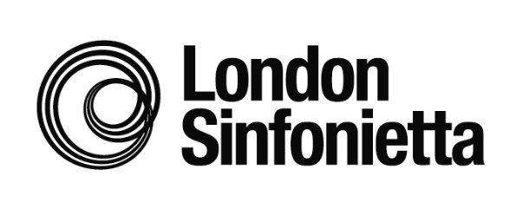

London Sinfonietta
Writing the Future: Open Call February 2020
Application Form

The London Sinfonietta is seeking music creators to join the next round of Writing the Future, an opportunity to make new work and build creative working relationships with the ensemble. For further details please see londonsinfonietta.org.uk/new-music/writing-future

We actively encourage applications from people from backgrounds that are currently under-represented in the classical music industry including Black, Asian and Minority Ethnic (BAME) and disabled candidates.

Please complete this form ensuring that links to videos are included where requested. The closing date for submission of all materials and details is Thursday 30 April 2020.

Digital Content: Please host all audio and video material relevant to your application on one of the following sites: Youtube, Vimeo, Soundcloud, Mixcloud.
Please ensure that any privacy settings are set up to allow us to access the material; if the material is password protected, please ensure that you include the password in your application. Please note that we will not be able to accept any files hosted on any private cloud based storage such as Google Drive or Dropbox. We will not be able to accept any audio or video files as part of your submission.

1. Personal details
Full name
Date of birth

Home address
Mobile phone number
Home/alternative phone number
E-mail address
Nationality
If you are not British then please state how long you have been resident / studying in this country
It is our policy keep in touch with scheme applicants about other relevant opportunities from the London Sinfonietta. Your details will not be passed to third parties. If you do not wish to receive these updates please tick this box.

Is there any further information you would like the London Sinfonietta to know? eg. Please let us know if you have medical needs, religious or access requirements.

2. Video link (compulsory)
Please provide a link below to your video, telling us about: you and the music you create; why you are interested in London Sinfonietta; how you think our input can specifically support your development.

This video does not need to be professionally filmed or edited.
Please host your video on Youtube, Vimeo, Soundcloud or Mixcloud ensuring that any privacy settings are set up to allow us to access the material, or if the material is password protected that you include the password below. We will not be able to accept any files hosted on any private cloud based storage such as Google Drive or Dropbox.

Link:
Password if applicable:

3. Project outline
Please explain your proposed project idea that you would like to develop and create through the scheme, detailing the involvement of London Sinfonietta musicians and briefly describing how your idea would be a new way of working within your own practice (max 300 words)

4. Please provide at least three examples of works you have created which demonstrate your style

Please provide links to audio tracks, videos or midi tracks – each example should be no more than 3 minutes (please indicate timings of specific sections if necessary).

Please host your material on Youtube, Vimeo, Soundcloud or Mixcloud, ensuring that any privacy settings are set up to allow us to access the material or if the material is password protected that you include the password below. We will not be able to accept any files hosted on any private cloud based storage such as Google Drive or Dropbox.

1
2
3
4

5. Referees
Please submit details of two referees who know you and your work, and can provide details of your suitability for this scheme. Please ask permission before submitting their names.
Referee 1: | Name:  Job title / occupation:  Email address:  Mobile phone:
Referee 2: | Name:  Job title / occupation:  Email address:  Mobile phone:

6. Declaration
I confirm that all the information I have supplied in this application is true, and the examples of the work I have submitted are my own. I understand that any false information or plagiarism will result in this application being rejected outright

London Sinfonietta is committed to processing your data securely and transparently. Please visit londonsinfonietta.org.uk/new-music/writing-future to download our Applicant Privacy Notice which sets out, in line with the Data Protection Act and GDPR, the types of data that we collect and hold on you and how the data is processed.
Please confirm that you have included the below as part of your completed application form

Video link and project outline |  | Yes | No
Names and contact details of 2 referees |  | Yes | No
Equality and Diversity monitoring form |  | Yes | No
Read and understood the Applicant Privacy notice |  | Yes | No
Signature |  | Date

Submitting your application
Applications and supporting materials should be sent by email to writingthefuture@londonsinfonietta.org.uk

The closing date for applications is Thursday 30 April 2020.

Late applications will unfortunately not be accepted. Please aim to submit your application as far in advance of the deadline as possible to facilitate the processing of applications.

If you have any questions or enquiries about this initiative please contact Natalie Marchant, Head of Concerts & Production (020 7239 9340 / writingthefuture@londonsinfonietta.org.uk )

